Week 8
Freedom

Day 5

NAME:______________________

Day 5 Agenda

Topic | Activity
Warm-Up!
English Language Arts | - Read and analyze and informational text about 9/11 and the Patriot Act of 2015.  - Develop an argument about their stance on the balance between National Security and Citizen’s Privacy.
Science | - Review the readings for this week  - Design your own Science Freedom Project  - Reflect
Mindfulness Moment!
Math | - Word Problems: Frosted Flakes, Pop Tarts and Milk: Freedom to Eat, A lot  - Skills: Fractions
Health | - What makes communities healthy or unhealthy?
Mindfulness Moment!
Civics/Social Studies | - Freedom of religion and religious tolerance around the world

Warm-up Activity: Write a journal entry around the daily quote on identity.
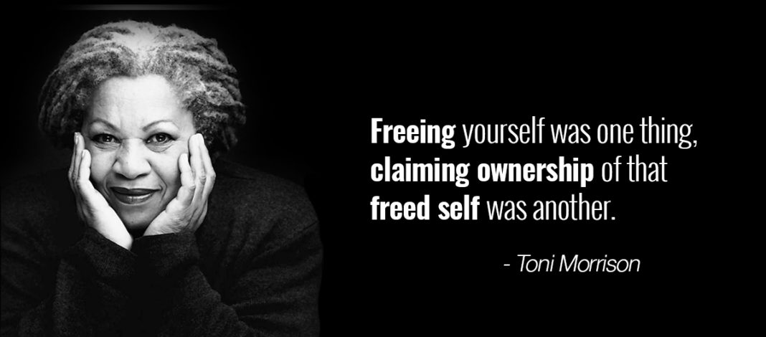

Day 5: Balancing Freedom and Public Safety
English Language Arts

What is this lesson about?
While we value our freedoms, it is important that we balance those freedoms with safety. After all, even though we have the freedom of speech, we are not allowed to yell “Fire!” in a movie theatre because it could cause panic and harm. This balance is often difficult to achieve. Ayour read and think about today’s lesson, think about that balance and how you would work to achieve the balance between freedom and responsibility in your own life.

Step 1: Read the following article

Before you read:
On September 11, 2001, 19 militants associated with the Islamic extremist group al Qaeda hijacked four airplanes and carried out suicide attacks against targets in the United States. Two of the planes were flown into the twin towers of the World Trade Center in New York City, a third plane hit the Pentagon just outside Washington, D.C., and the fourth plane crashed in a field in Shanksville, Pennsylvania. Almost 3,000 people were killed during the 9/11 terrorist attacks, which triggered major U.S. initiatives to combat terrorism and defined the presidency of George W. Bush.

After September 11, frightened Americans wanted something to be done to protect the United States from another terrorist attack. Responding to this overpowering public sentiment, and to the enormous sense of vulnerability revealed by the successful Al Qaeda strike against the United States, the Bush Administration hurried to put in place a set of measures that would answer public concerns and improve the nation’s ability to cope with terrorism. The agenda of steps and measures that followed were regarded as a program for “Homeland Security” – a program that was regarded, at least initially, as a major national priority.

The lesson below was taken and adapted from: https://newseumed.org/tools/critical-debate/2015-debating-usa-patriot-act

Some Vocabulary to Review.
tangible: able to be touched | chilling effect: frightening | bulk: in large amounts
hail: praise | lapse: a stop or pause | expeditious: quickly and efficiently

Case Study Background: USA PATRIOT Act (2015)

Less than two months after the Sept. 11, 2001, terror attacks, President George W. Bush signed the USA PATRIOT Act – that stands for "Uniting and Strengthening America by Providing Appropriate Tools Required to Intercept and Obstruct Terrorism.” The legislation was rushed through Congress, intended to strengthen the ability of law enforcement and government agencies to pursue suspected terrorists quickly. It included a number of controversial sections that sparked debate over how much power the government should have to spy on its citizens and whether the government’s increased security measures would make people fearful of exercising their freedom of speech.

The law included several sections that directly impacted freedom of speech, including a ban on supplying any form of “material support” to terrorist groups. This ban was built on existing federal laws, but the USA PATRIOT Act expanded the definition of “material support” to include not only goods or money but also “expert assistance or advice.” In other words, speech alone – advising a designated terrorist group, even if the advice dealt with a peaceful and lawful subject – would violate the law. The act also broadened the power of government officials to secretly gather public library records, Internet usage logs and “any tangible things” in the course of their investigations, which some argued could have a chilling effect on free speech. In later years, it was revealed that the government was also collecting massive amounts of email and phone call data with no direct ties to specific, active investigations – a practice termed bulk metadata collection.

From the beginning, the PATRIOT Act carried a built-in expiration date that would require lawmakers to reconsider its necessity and reach. The PATRIOT Act was first renewed in 2006. Many parts were made permanent, and the more controversial sections were renewed through 2009. After an extension, it was renewed again in 2010 for an additional year. Renewal passed again in 2011, when a new expiration date of June 30, 2015, was set.

In 2015, the Senate failed to pass the PATRIOT Act renewal before the expiration deadline. President Barack Obama stressed the importance of renewing the law to enable the government to fully protect its citizens and urged the Senate to act quickly. Without the PATRIOT Act, the government would lose its power for bulk metadata collection, to issue special warrants allowing monitoring of all of a suspect’s electronic devices, and to use anti-terror investigation methods against “lone wolf” terrorists who were not part of known terror groups.

Some senators wanted this outcome of stripped powers. Sen. Rand Paul, R-Ky., spoke on the floor of Congress for 11 hours in opposition to the act. However, there was not enough support to fully block the law’s renewal. On July 2, the Senate effectively renewed the PATRIOT Act, one day late, by approving legislation called the USA Freedom Act.

The powers the USA Freedom Act grants the government are largely the same as those in the PATRIOT Act, with one key difference. The USA Freedom Act changes the method of bulk metadata collection by making phone and Internet companies responsible for storing data on their users rather than allowing the government to collect and store all such data. The government must then obtain targeted warrants to access information that has been collected. Supporters of the bill hailed it as the first step toward rolling back the post-9/11 expansion of the government’s power to spy on its citizens. Some opponents of the PATRIOT Act renewal, including Sen. Paul, did not feel this change went far enough and did not vote for the USA Freedom Act.

Within hours after the Senate passed the USA Freedom Act, President Obama signed it into law. "After a needless delay and inexcusable lapse in important national security authorities,” he said in a statement, “my administration will work expeditiously to ensure our national security professionals again have the full set of vital tools they need to continue protecting the country.”

Step 2: Answer the Following Questions

- What are the responsibilities of an elected representative? How should constituents’ feedback – exercising their right to petition the government – affect your actions?

- Do you think the government should have access to the phone calls and emails of suspected terrorists? How should it identify “suspected terrorists”?

- How would it make you feel if you found out that the government could access your phone calls and emails? Would you change what you said/wrote in any way?

- Does knowing the government has far-reaching powers to gather information on individuals’ phone calls, emails, Internet usage, etc., suppress free speech?

- What effect might another major terrorist attack on U.S. soil have on individuals’ ability to exercise their freedoms?

Step 3: Consider your opinion and prepare an argument

EXPLORE THE DEBATE
What would you do if you had to decide whether the government should have power to monitor citizens’ phone calls and emails to fight terrorism?

THE CASE
You are a U.S. senator facing an upcoming vote on whether to renew provisions of a law that gives the government wide-reaching powers to investigate possible terrorists and terrorism organizations. The law was passed more than a decade earlier, in the wake of a devastating terrorist attack. In the years since, there has been intense debate over whether the law goes too far. A particularly controversial portion of the law gives the government the power to collect Americans' phone call records and emails in bulk for potential use in investigations.

You know that your constituents want to be safe, and you want to use your position of power to help prevent future terrorist attacks. However, some of your constituents say this law gives the government too much power, violates their privacy and makes them feel wary of exercising their freedom of speech. How will you vote?

PICK A POSITION
1. Vote to renew the provisions. Protecting the country from future terrorist attacks is the most important goal.
2. Do not vote to renew the law. The powers it grants the government go too far and are no longer needed.
3. Propose a new, alternative law that keeps many of the expanded government powers in the original law, but more closely regulates the bulk data collection. Attempt to find a more delicate balance between empowering terrorism investigations and citizens’ rights.
4. Abstain from the vote. This issue is too controversial, and a vote either way is likely to alienate a large portion of your constituents.
5. Something else. Explain your idea.

Explain your choice below. Write your explanation in the form of a speech. Your audience is your constituents--the people you represent. Some may agree with the law, while others may not. Remember that you represent all of them as you present why you made your choice and why you believe it is the best choice for them.

Step 3: Share your response with a partner
As you discuss your responses, think about where you agree and where you disagree. Is there room for a compromise?

Student Feedback:
Circle the emojis that best represents how this activity made you feel. | 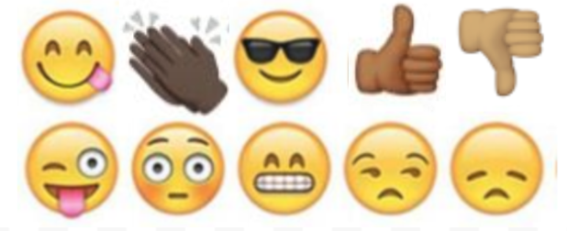  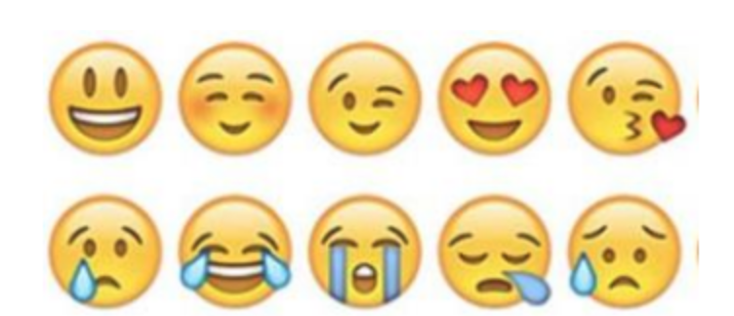

Day 5: Design your own Science Freedom Project
Science

What is this lesson about?: Today you will review this week’s readings. You will design your own Science Freedom Project. You will reflect on this week’s lessons.

Step 1: Review this week’s readings

Step 2: Design your own Science Freedom Project

Choose one of the projects below or design your own Science Freedom Project. You will complete this project on the next page, which is blank. Be prepared to share your project with your class.
- Draw a picture of two animals and two plants that most represent freedom to you. Explain.
- What kind of animal do you believe experiences the most freedom in its lifetime? Draw a picture and explain.
- Draw an image showing how humans have impacted the freedom of any two types of animals. Show at least one positive impact and one negative impact. Explain.
- Draw an image that shows what is needed for human beings to be free. Is 100% freedom possible? Explain.

Step 3: Reflect

As you think about this week’s science lessons, what’s one thing you will remember about freedom?

Student Feedback:
Circle the emojis that best represents how this activity made you feel.

Page for your project

Mindfulness Moment!

One of the coolest things I have ever seen is...

Day 5: Freedom/Fractions
Math

What is this lesson about?: Today you will learn about equivalent fractions.

Warm Up and Review Problems:
Malcolm was born in Philadelphia, PA. Over the first 12 years of his life he lived with 6 different families, as a foster care kid. Later, he moved to Florida, near Tampa. He lived there until he turned 17, when he moved to Baltimore, MD, to live with some family friends. From 13 to 17 he was in and out of juvenile facilities in Florida four times.

He is now 22. He attends college part-time, and works 20+ hours per week in a restaurant. He is 1 and ½ years away from earning his degree in criminal justice. He hopes to work with court-involved students once he graduates.

We asked him a few questions, about what Freedom means to him, at age 22 and used his responses to create some math questions about Freedom.

Malcolm says he was always hungry growing up, so whenever he gets a chance to eat a full meal, he does, plus some.

His favorite breakfast is a bowl of frosted flakes, 2 poptarts crumbled up in it and a cup of milk. He estimates that he eats a whole box of cereal in 5 days. If a box of frosted flakes costs $4.50, and a box of 10 pop tarts costs $4.00 and a gallon of milk (16 cups), how much, approximately, does his bowl of cereal cost him?

For dinner, he loves going to Wendy’s. He usually orders two sandwiches/burgers, a large fries and a large drink. He says he stops at Wendy’s 2xs per week when he finishes work. He says the burgers he really likes cost $3.50 each, the fries cost $2.75 and he gets his drink for free. How much does he spend on this dinner by eating it 2xs/week?

Malcolm also loves socks….he said that growing up he never had nice socks...So he has lots of pairs of socks, and is always getting them for gifts. He says that he has about 40 pairs of socks. On average, he says they cost about $4.50/pair. What’s the value of his socks?

Malcolm has to pay for his own college. Because he goes to the local community college, classes cost about $1600 per semester. Malcolm qualifies for 60% of his costs to be covered by a Pell Grant. How much is left for him to pay each semester, after his Pell Grant?

We asked Malcolm what Freedom meant to him at age 22. He said that Freedom is being able to go to the community college gym and work out by just showing his college ID, that Freedom is having his own room, and that Freedom will be getting a car in a couple years...
Activities/Fraction Problems: Complete the following fractions worksheets.
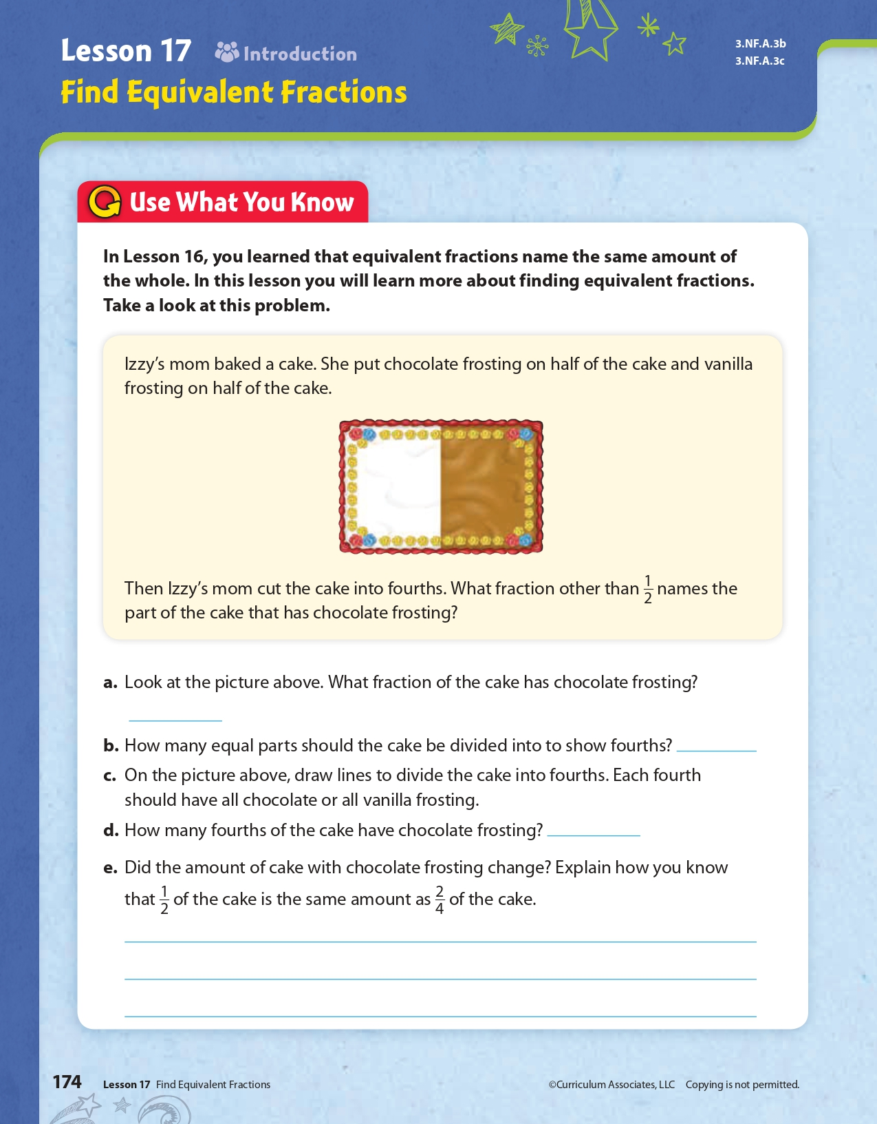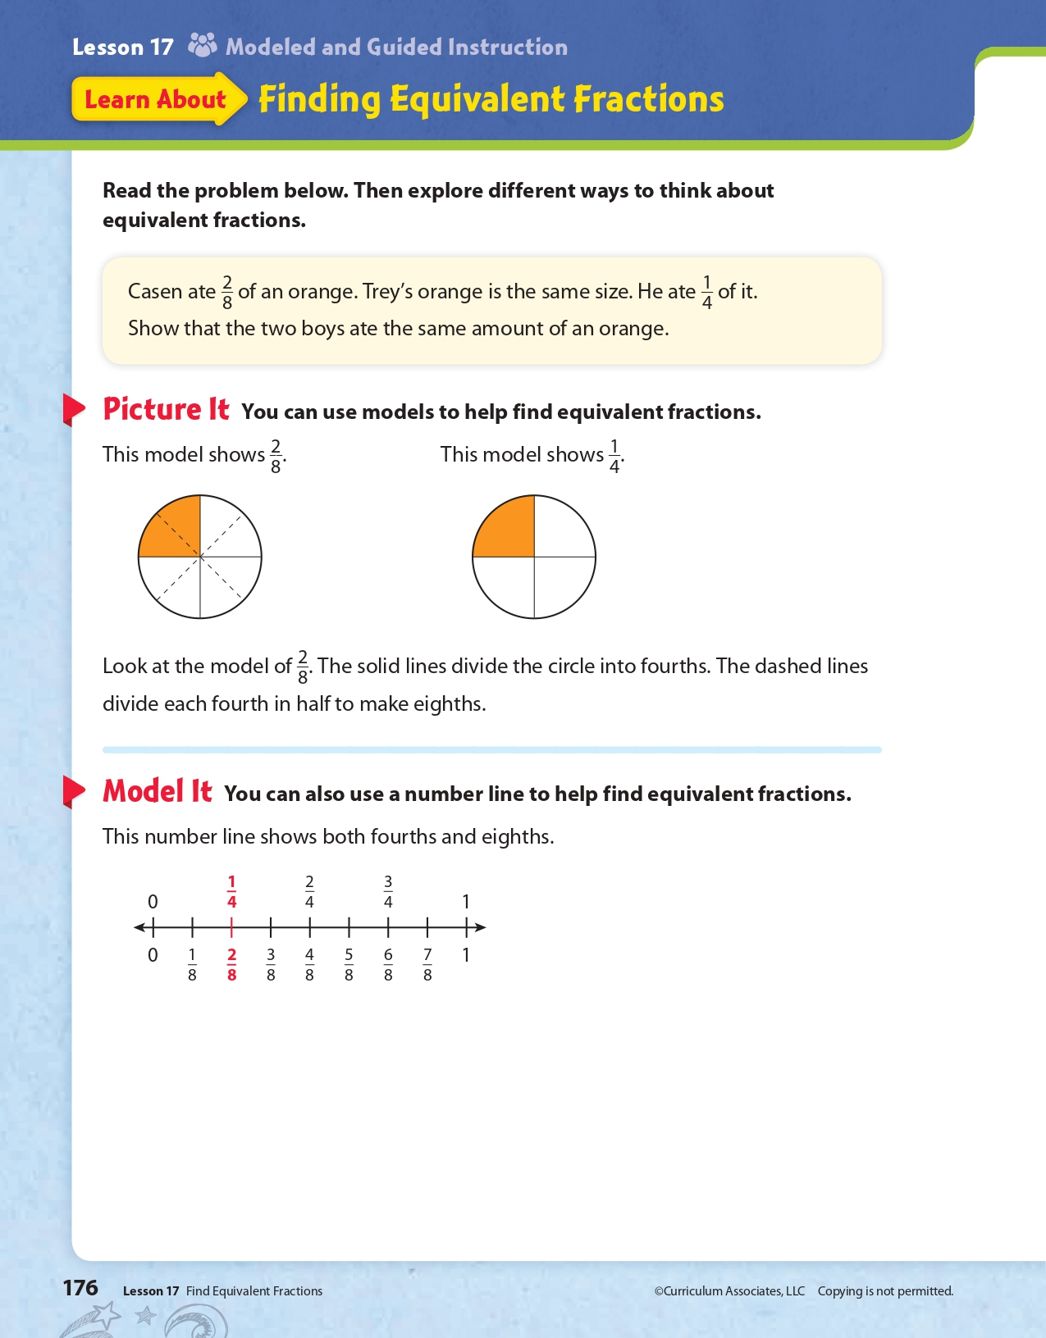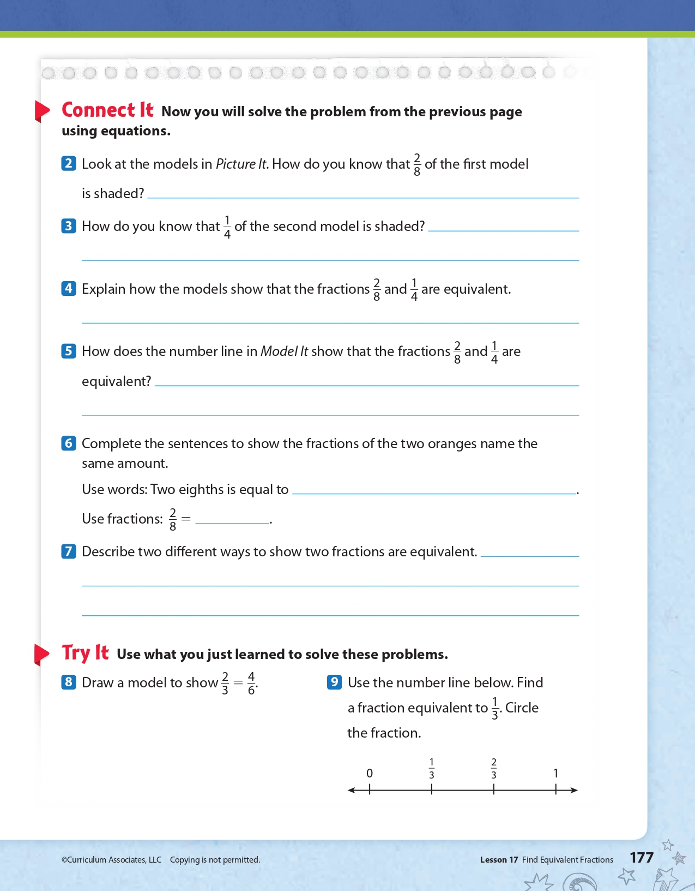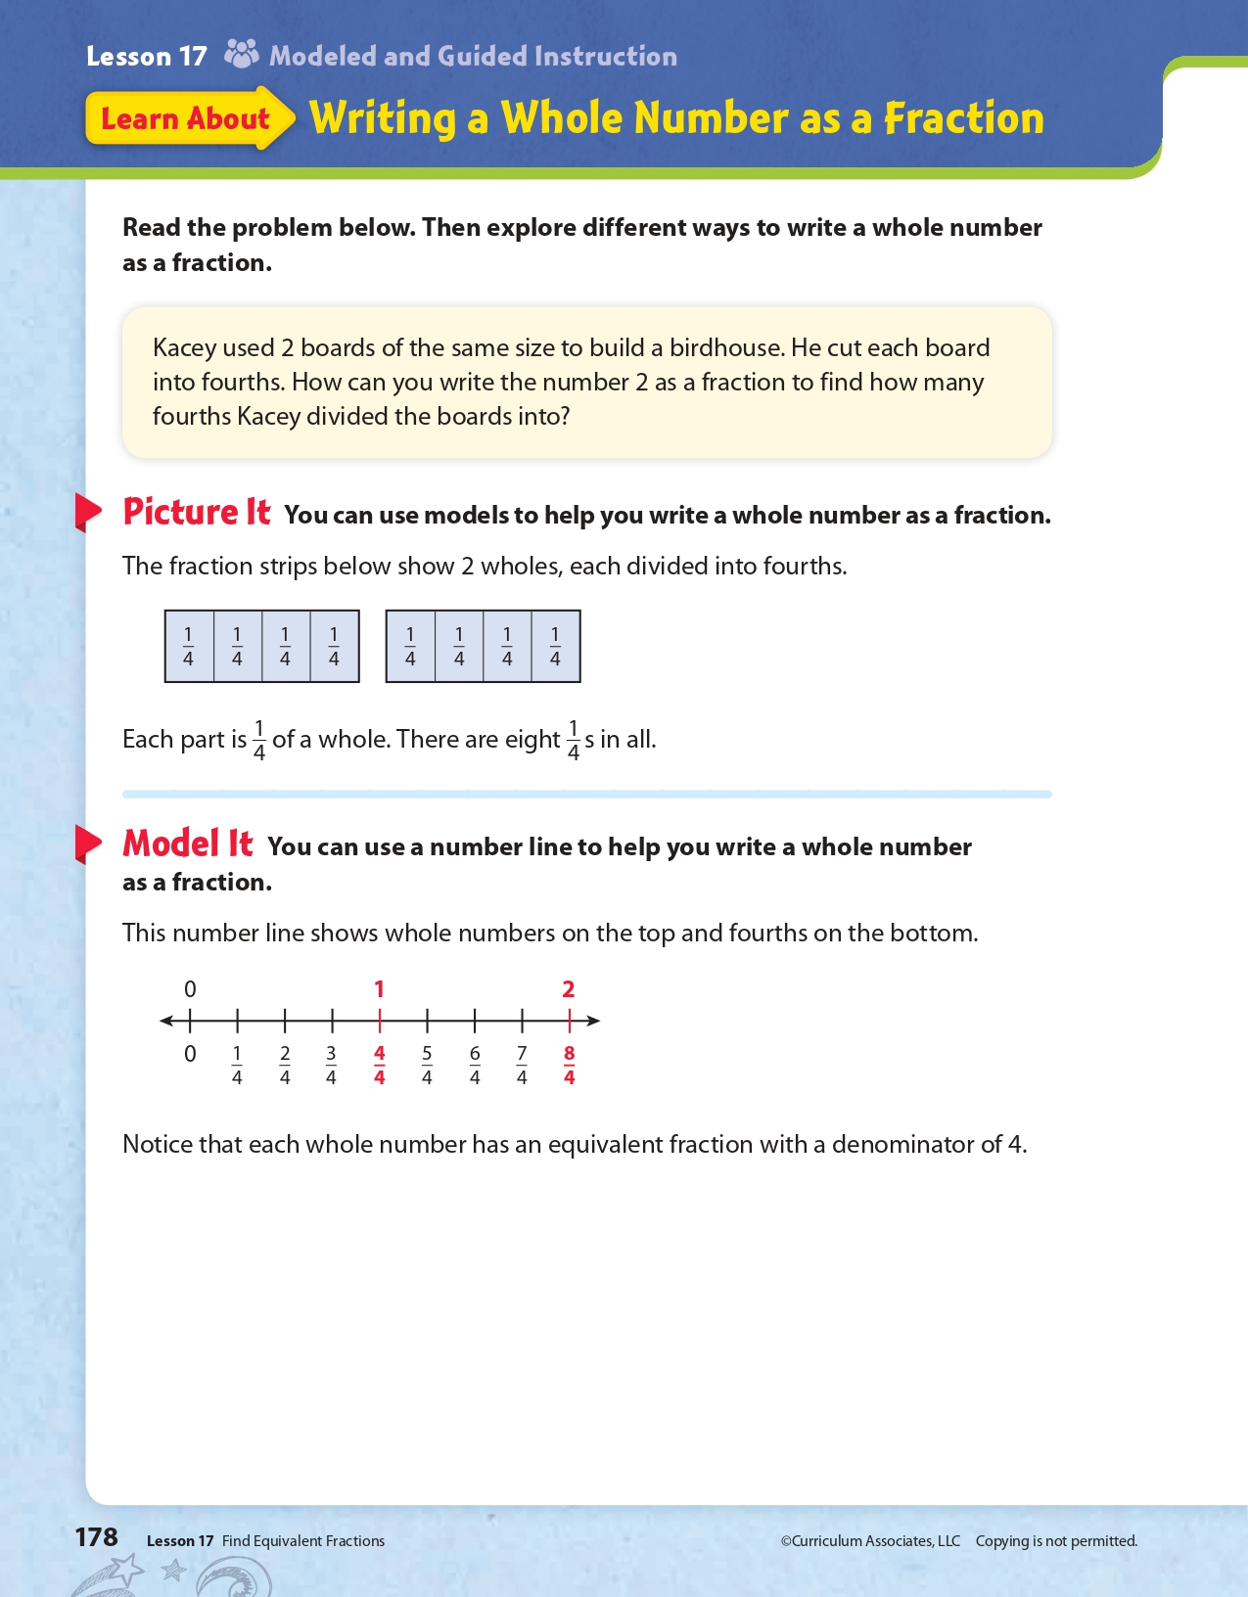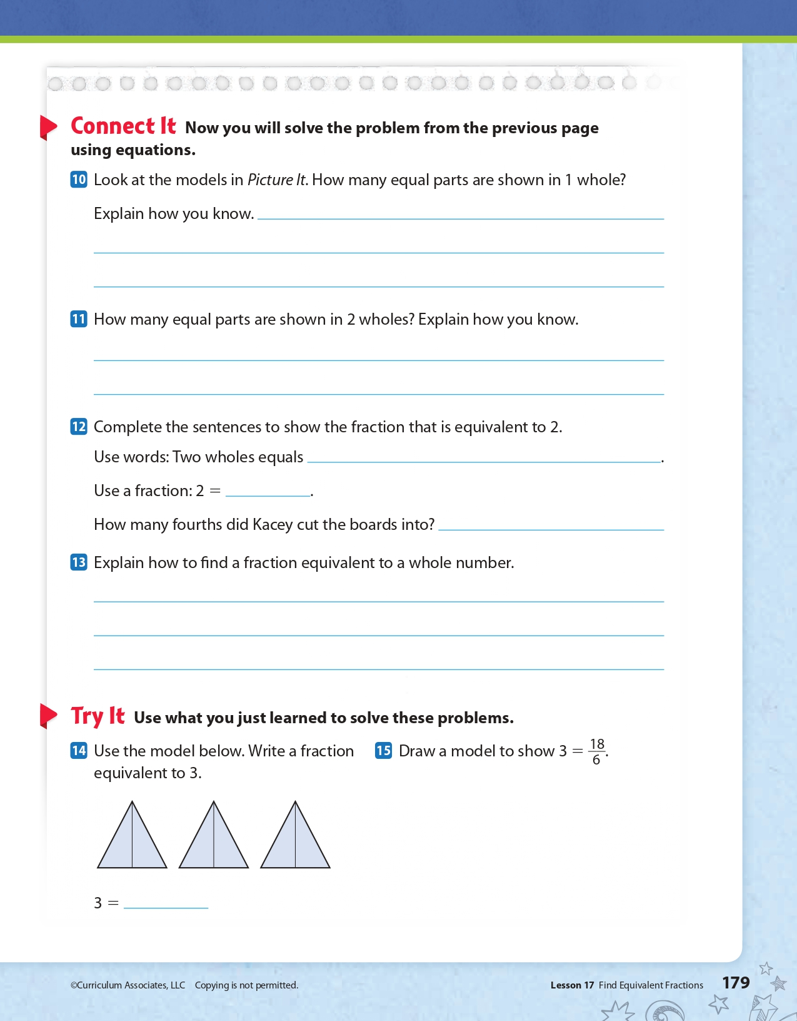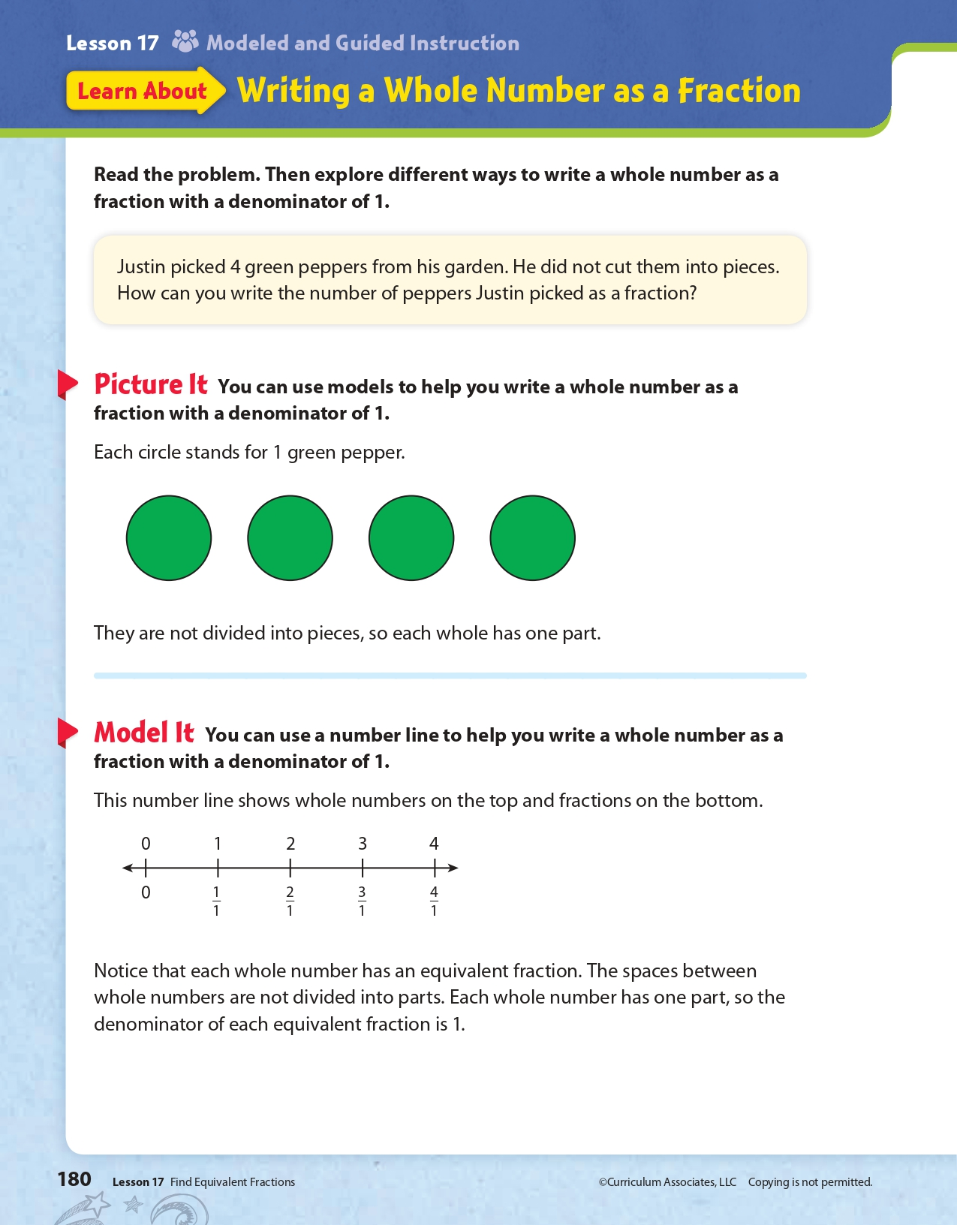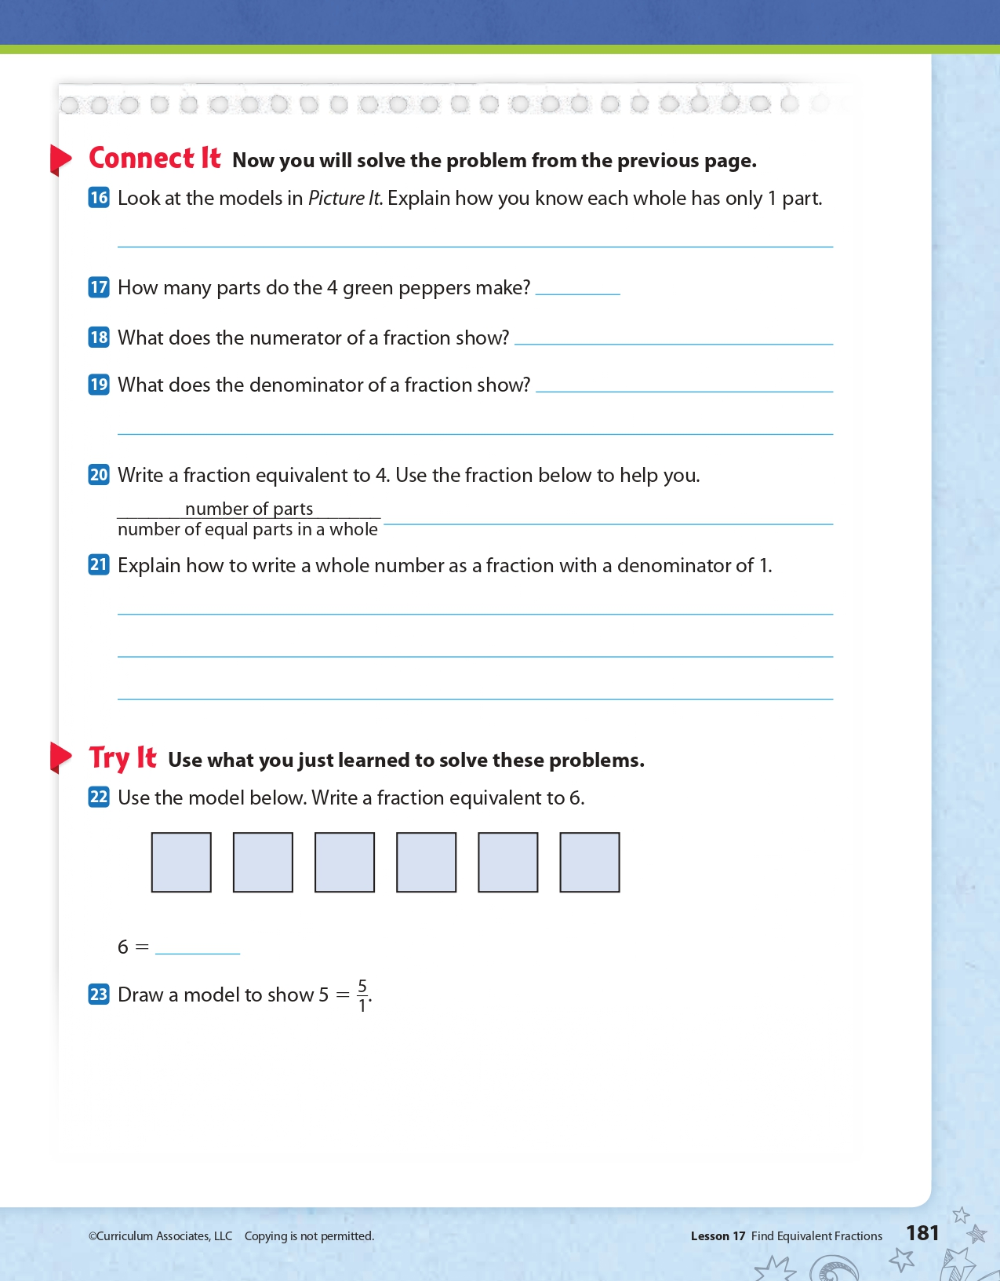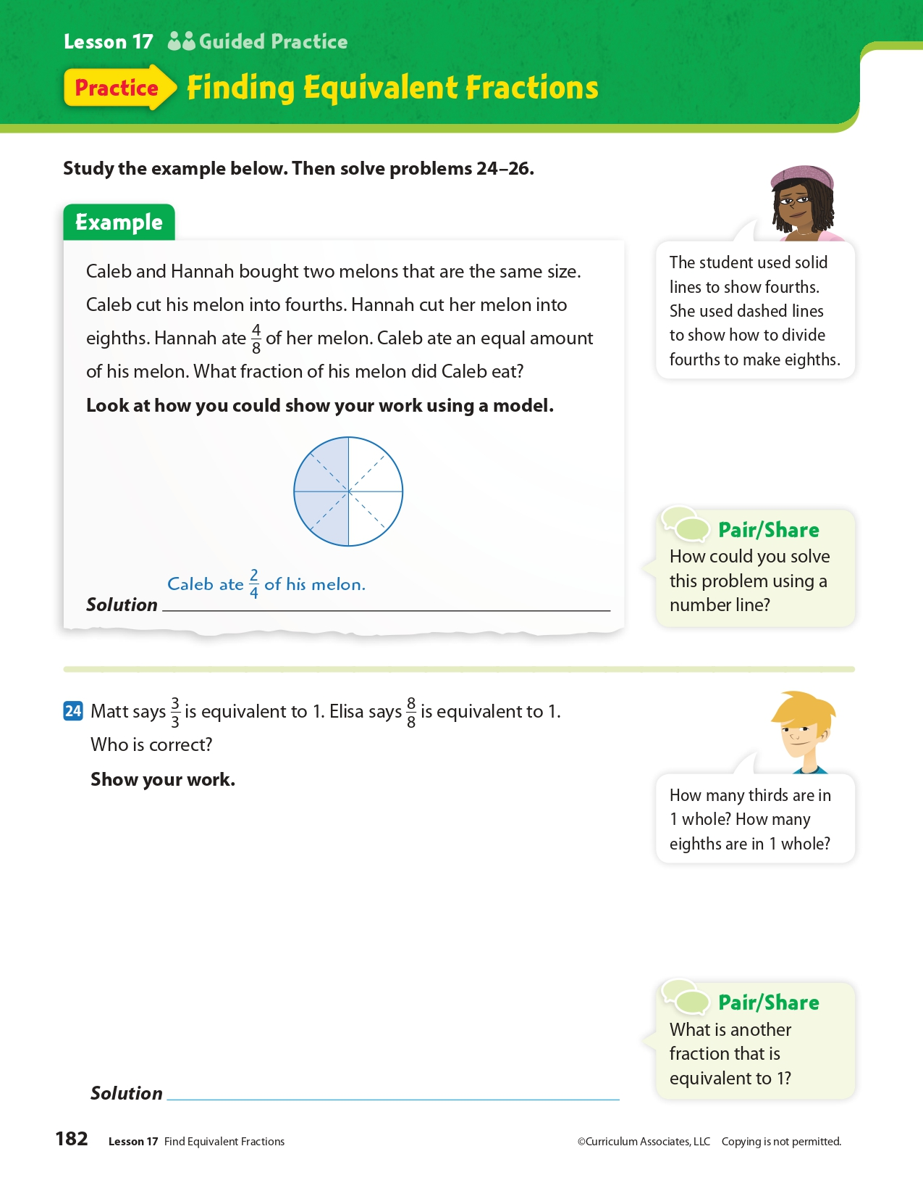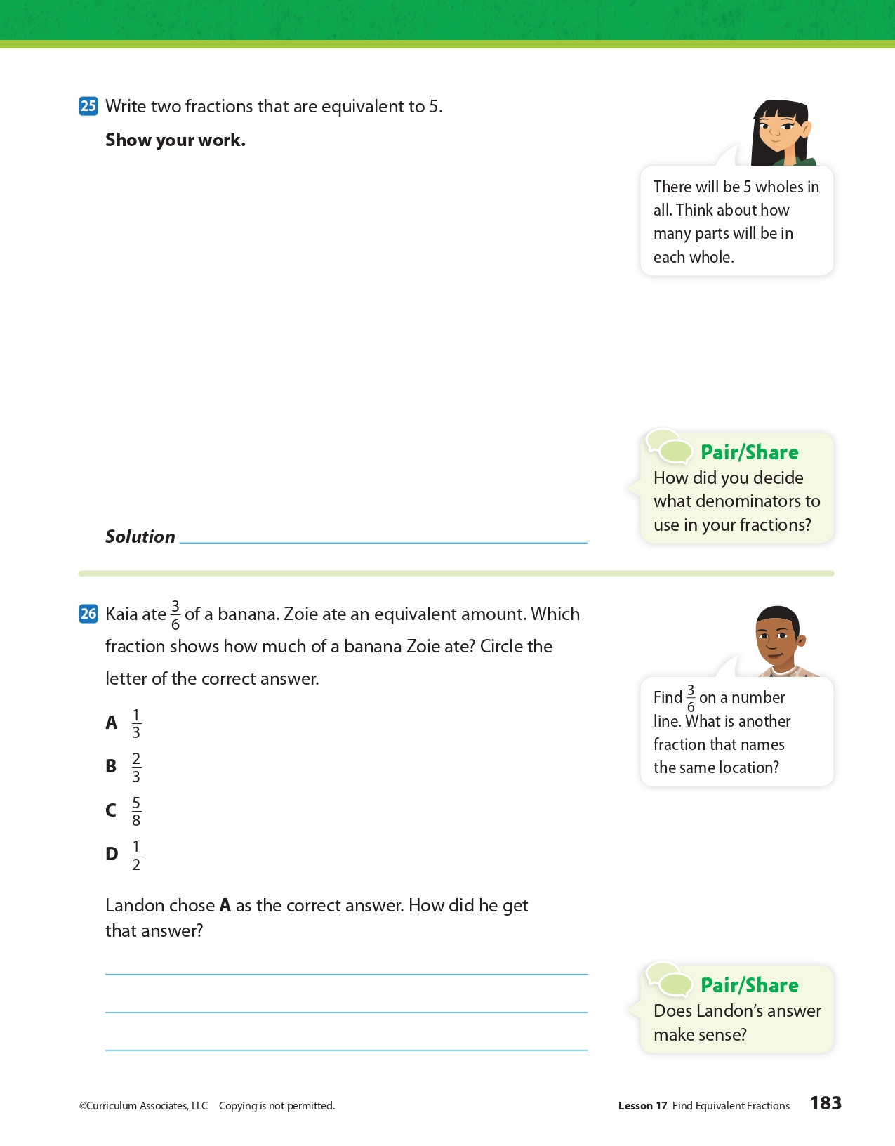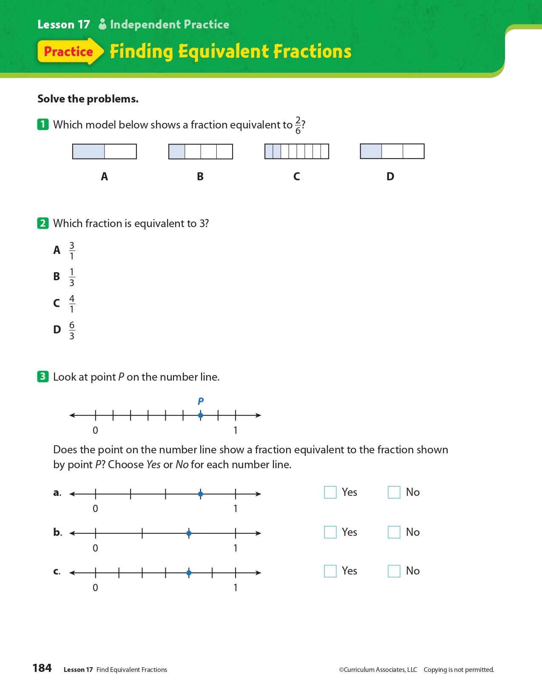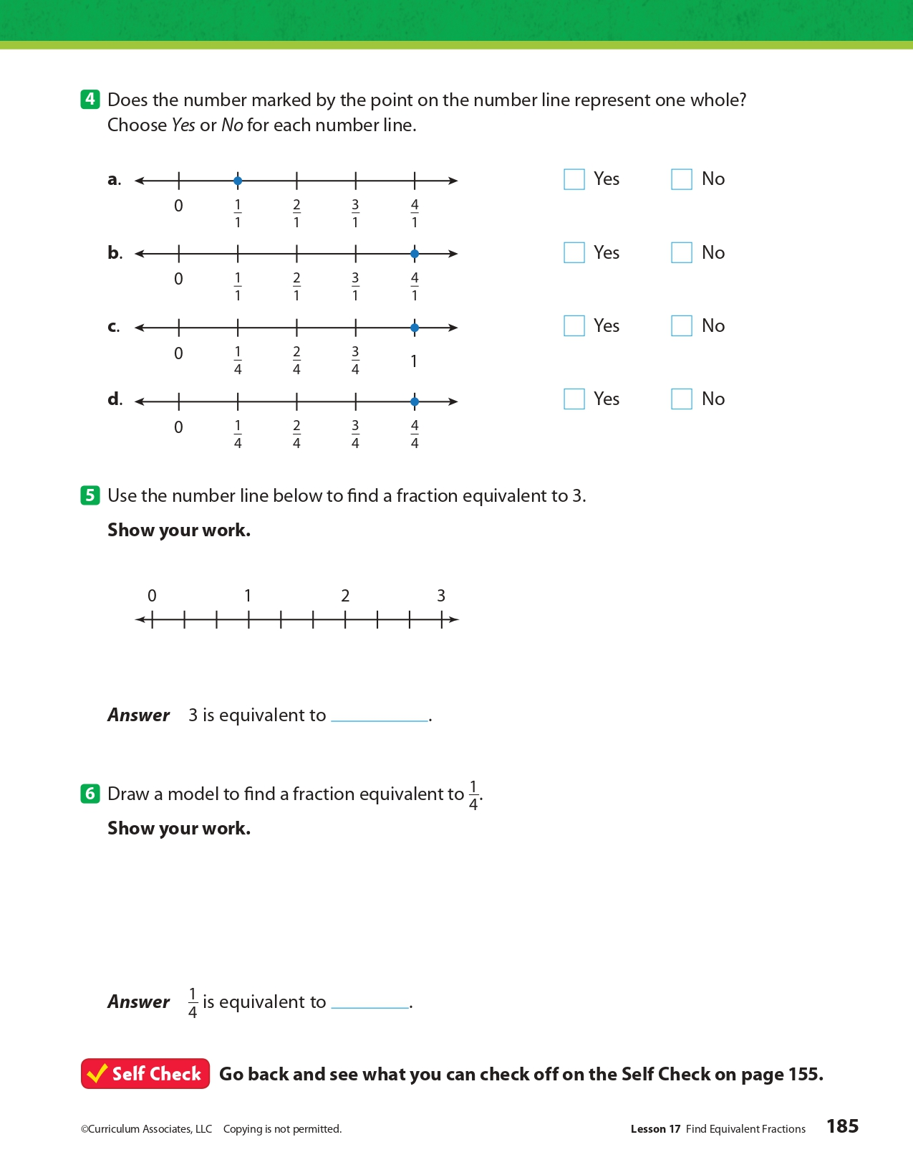
Day 5: What makes communities healthy or unhealthy?
Health

What is this lesson about?: In today’s lesson, you will consider hate speech in relation to the First Amendment and how it affects the health of a community.

Step 1: Warm-Up:

Write a short journal entry describing an incident in which you or someone you know has been the target of hate speech of any kind. If you cannot think of one, you can describe an incident in literature, on television, or in the movies.

Step 2: Read the story below.

Hate speech is an expression that mocks or belittles a person because he or she may belong to a certain social group. That group may be a certain race, ethnicity, gender, sexual orientation, religion, age, someone with physical or mental disability or something else.
Typical hate speech involves labels and slurs. Hate speech can be directed so people inflict hatred or violence against a group. Some hate speech involves cruel stereotypes — believing that all people of one group act a certain way, or have a certain attribute.
Hate speech can also include unspoken pictures and symbols. For example, the Nazi swastika and the Confederate battle flag (of the Confederate States of America) are considered hate speech by many people.
Critics of hate speech argue that it causes psychological harm to its victims, and physical harm when it incites violence. They also say that it makes its victims less equal in society. That is particularly true, they claim, because hate speech is usually directed at marginalized groups — people who have less power in society.

The Ongoing Debate About Hate Speech
Therefore, hate speech poses a challenge for modern, free societies. Free, democratic nations believe that all people are equal, but they should also be free to express themselves and their feelings. Thus, there is an ongoing debate in those societies: Should hate speech be regulated or censored? If so, how?
In the traditional idea of what liberal, democratic societies should be, all speech is typically allowed — even hate speech. A person may be disgusted by hate speech. But they may also find it worse to allow their government to censor the words of a citizen, even if those words are bigoted or hateful.
Any censorship, they might say, would lead to more censorship by a government. If the government were allowed more freedom to censor, who's to say they wouldn't censor anything that is unpopular? That could mean that something important, like criticism of the government, might get censored just because some people didn't like it. This kind of censorship would be unthinkable: Criticism of government is key to the health of a free, open democracy.

Discussing And Agreeing On Ideas
Some people argue that the best way to fight hate speech is to point out how wrong and false it is as an idea. In this "liberal" society, there's an "open exchange of ideas." In this situation, all ideas are to be discussed and debated. Society then comes to an agreement about what ideas it wants or doesn't want.
Some people believe that hate speech should be censored. They typically argue against the traditional liberal model above, which says that all people and groups are equal in society. The "open exchange of ideas" doesn't fairly recognize the fact that there are marginalized groups who could get hurt because of hate speech.
Hate speech, they argue, is not simply the "free expression of ideas." It actually causes its victims to be unsafe and lesser in society. When aimed at oppressed minorities and other people of color, hate speech is not just insulting — it also continues the oppression of these minorities. It causes the victims, the people spewing hate and the rest of society to absorb the hateful messages and act on that hate.

U.S. Courts Don't Censor Hate Speech
To them, victims of hate speech cannot enter the “open marketplace of ideas” as equal participants to defend themselves. For them, hate speech is part of a broader system of inequality and unjust discrimination. It just causes more problems for the victims, effectively silencing them.
The United States protects freedom of speech in the First Amendment. U.S. courts have generally ruled against attempts to censor hate speech. The only exceptions are if hate speech is being used to incite immediate harm to a person or group.
Other liberal democracies such as France, Germany, Canada and New Zealand have laws designed to lessen hate speech. Such laws have gotten more popular since World War II.

Step 3: Answer some questions below.

- Do you think we should censor speech or have an “open exchange of ideas? Why?

- Why do you think laws in France and Germany have gotten more popular since WWII?

- Why do you think hate crimes and hate speech are viewed differently in the eyes of the court? (hate crime laws include crimes committed on the basis of the victim’s perceived or actual race, color, religion, national origin, sexual orientation, gender, gender identity, or disability.)

Step 4: Practice scenario

A student in your class just used hate speech (Calling people names based on their race, religion, national origin, disability, gender, sexual orientation, or any other type of group that is disenfranchised in our society) against another student. How would you respond?

You:

Student Feedback:
Circle the emojis that best represents how this activity made you feel.

Mindfulness Moment!

A challenge that helped me learn and grow was...

Day 5: Freedom of Religion & Religious Tolerance Around the World
Social Studies

What is this lesson about?: So far this week you have learned about religious freedom in the United States. Today, you will explore whether religious freedom exists throughout the world.

Step 1: Warm-up on religious liberty

In Pakistan, Asia Bibi was convicted on blasphemy charges in 2009 after a quarrel with a fellow farmworker who accused her of insulting Islam's Prophet Muhammad. After spending eight years on death row, the 54-year-old’s conviction was overturned by Pakistan’s Supreme Court. Despite being a “free woman” after the death sentence was thrown out, she has been in protective custody - itself a kind of prison - because of religious extremists' calls for her hanging. Do you think someone should face these consequences just because they have different religious beliefs?

Step 2: What is religious tolerance?

The term "religious tolerance" can apply to governments, religions, faith groups, individuals, etc. It can involve:
- Allowing others to freely hold different religious beliefs. This includes granting everyone freedom of personal belief, and freedom of religious speech
- Allowing others to freely change their religion, or denomination or beliefs.
- Allowing children to hold religious beliefs that are different from their parents to a degree that depends on their age.
- Allowing others to practice their religious faith, within reasonable limits. This includes granting everyone freedom of assembly and freedom to practice what their religion requires of them.
- Refusing to discriminate in employment, accommodation etc. on religious grounds.
- Accepting that followers of various religions consider their own beliefs to be true.
- Making a reasonable effort to accommodate other people's religious needs. For example:
  - Allowing an employee to work overtime in order to take off a religious festival or holy day that is significant to them.
  - Scheduling meetings so that they do not conflict with common holy days.

Do you think there is religious tolerance in the U.S. ? Why or why not?

Do you think the 1st Amendment’s freedom of religion clause establishes tolerance? Explain.

Step 3: Read the article

Religious Restrictions Growing Around the World, Study Finds

The Middle East witnesses the highest levels of restrictions, while Europe sees the largest increase in hostilities directed at religion, Pew report finds.
By Lauren Favre ContributorJuly 17, 2019, at 5:00 p.m.

RATHER THAN PROGRESSING to provide openness and inclusivity, countries imposed an increasing number of restrictions on religion over a decade, according to a newly published international study.
Additionally, the number of countries where people are experiencing the highest levels of social hostilities involving religion rose by more than 40 percent over the same period, according to the report produced by the nonpartisan Pew Research Center.
To provide a broader understanding of how the global situation has changed, the report, entitled, "A Closer Look at How Religious Restrictions Have Risen Around the World," covered a 10-year span, from 2007 to 2017. The study tracked 198 countries within five particular regions: the Americas, Asia-Pacific, Europe, Middle East-North Africa and sub-Saharan Africa. The study broke down the two indexes, government restrictions and social hostilities, into four categories each.
While some governments scored particularly high in specific categories, the Middle East-North Africa region, with its relatively high level of government restrictions on religion, ranked highest each year of the study. Fifty-two governments, including China and Russia, were found to impose either "high" or "very high" levels of restrictions on religion, a significant increase from the 40 countries so designated in 2007, when the study began.
The most prevalent categories of government restrictions have consistently been "government favoritism of religious groups," such as the 17 Middle Eastern countries that have an official state religion, and "law and policies restricting religious freedom," such as in Eritrea where the government only recognizes and registers four religious groups. During the past decade, the global average score in the two categories increased by more than 20 percent.
The two other categories, "government limits on religious activities" and "government harassment of religious groups," also increased over the 10-year period, although at lower levels. In 2011, France banned full-face coverings, prohibiting Muslim women from wearing the burqa or niqab in public. And in the Maldives, as noted by the U.S. State Department, it's a criminal offense to promote a religion other than Islam. Violence, intimidation and other types of harassment were found to take place in numerous countries, including Myanmar and China, the Pew report found.
In Myanmar, more than 700,000 ethnic Rohingya have fled to neighboring Bangladesh since the Myanmar military launched a clearance campaign in 2017 against the Muslim group. And earlier in July, nearly two dozen countries called on China to halt its mass detention of ethnic Uighurs, Reuters reported. U.N. experts say at least 1 million Uighurs and other Muslims are being held in detention centers.
The Social Hostilities Index examined acts of religious hostility by private individuals, organizations or groups through four categories: hostilities related to religious norms, inter-religious tension and violence, religious violence by organized groups and individual and social group harassment. The largest increase in social hostilities related to religious norms occurred in Europe, where incidents of threats and violence multiplied throughout the span of the study.
Unlike the other categories, since 2007 interreligious tension and violence decreased in most regions, with the exception of sub-Saharan Africa. Europe and the Middle East-North Africa region saw the largest increases in religious violence by organized groups. ISIS and other terrorist groups have committed deadly attacks, including the incident on Palm Sunday and the attack on a Sufi mosque in northern Sinai.
The Americas were found to have the lowest levels of individual and social group harassment, while the Middle East and North Africa almost always had the highest hostilities.
What does this article tell you about religious freedoms throughout the world? Choose three things to write down.

Step 4: Consider the pictures below
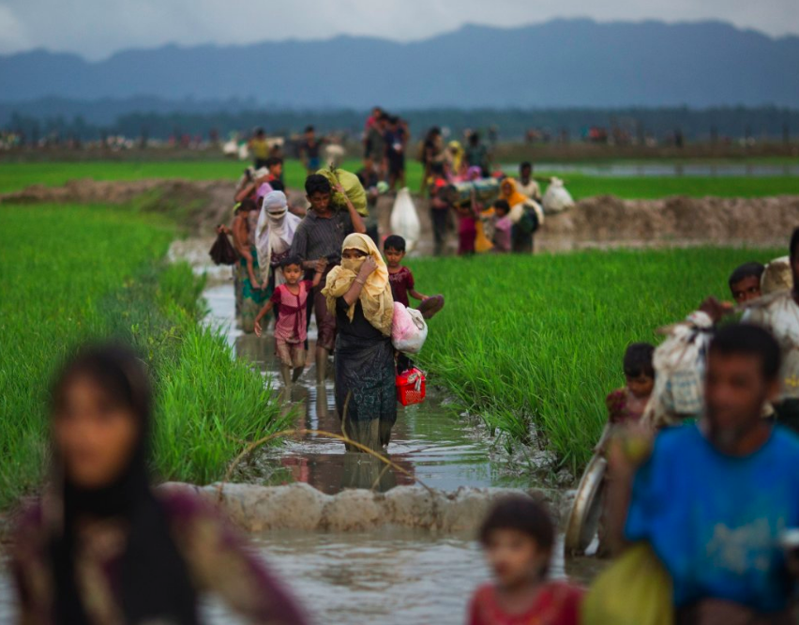
Sept. 1, 2017 | Members of Myanmar's Rohingya ethnic minority group walk through rice fields after crossing over to the Bangladesh side of the border near Cox's Bazar's Teknaf area. Thousands of Rohingya Muslims are pouring into Bangladesh as part of an exodus of the beleaguered group from neighboring Myanmar that began when violence erupted there on Aug. 25. Most of Myanmar's estimated 1 million Rohingya live in northern Rakhine state. With the government refusing to recognize them as a legitimate native ethnic minority, they face severe persecution, leaving them without citizenship and basic rights.

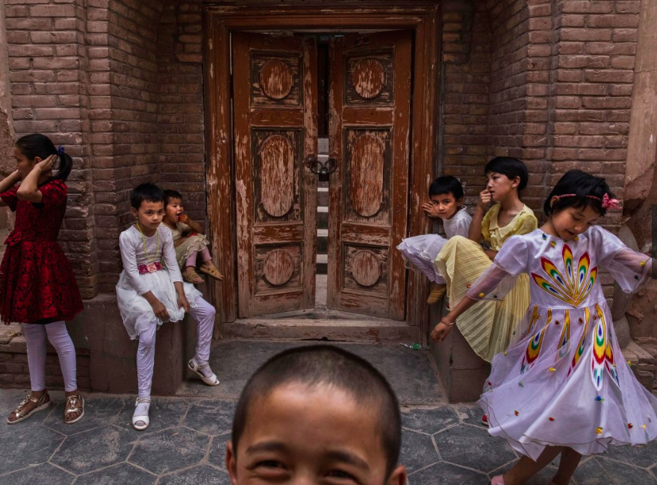
June 27, 2017 | Uighur children sit outside a local mosque that was shut down by authorities.

KASHGAR, CHINA - Kashgar has long been considered the cultural heart of Xinjiang for the region's nearly 10 million Muslim Uighurs. At a historic crossroads linking China to Asia, the Middle East and Europe, the city has changed under Chinese rule with government development, unofficial Han Chinese settlement to the western autonomous region, and restrictions imposed by the Communist Party. Beijing says it regards Kashgar's development as an improvement to the local economy, but many Uighurs consider it a threat that is eroding their language, traditions and cultural identity. The friction has fueled a separatist movement that has sometimes turned violent, triggering a crackdown on what China's government considers 'terrorist acts' by religious extremists. Tension has increased with stepped up security in the city and the enforcement of measures including restrictions at mosques.
Step 5: Read the article

The 10 Countries With the Most Religious Freedom, Ranked by Perception

Respondents to the 2019 Best Countries survey say these nations offer the most religious freedom.
By U.S. News Staff May 3, 2019,

The attack on a synagogue outside of San Diego in late April 2019, where a gunman opened fire and killed one woman and wounded three others, is the latest incident where individuals have targeted places of worship around the world. In the past six months a series of deadly explosions hit Christian churches across Sri Lanka on Easter; mass shootings occurred at mosques in New Zealand in March; and a deadly shooting took place at another synagogue in the U.S. last October, in Pittsburgh, Pennsylvania.

The attacks raise questions about the freedom to practice religion in countries without fear of being attacked, or restricted by governments. In 2018, the nonpartisan Pew Research Center published an analysis noting that restrictions on religion continued to increase around the world. However, the study also noted that most countries still have low to moderate levels of religious restrictions.
European, North American and Asia-Pacific countries dominate the rankings of nations seen to offer the greatest amount of religious freedom, according to the 2019 Best Countries report. The Best Countries survey is based on a study that surveyed more than 20,000 global citizens from four regions to assess perceptions of 80 countries on 75 different metrics. Being seen as offering religious freedom is one of eight equally weighted country attributes used to develop the Best Countries Citizenship sub-ranking.

The following are the top 10 countries viewed as offering the greatest levels of religious freedom.
- Netherlands
- Canada
- Norway
- Australia
- United States
- United Kingdom
- Belgium
- Denmark
- New Zealand
- Sweden

Step 6: Reflect and answer questions

As you learned this week, you have freedom of religion here in the U.S. How do you practice your religious freedom?

Do you think the U.S. Founders did a good thing by creating freedom of religion in the Bill of Rights? Was their idea relevant to today’s world?

Reconsider your answer to the following questions above: Do you think there is religious tolerance in the U.S. ? Why or why not?... After considering the articles you read today, does your answer change at all? Explain.

Think about your own neighborhood. How might the U.S. society, your neighborhood included, help to respect people’s freedom of religion more carefully? Do you have any ideas on how we, as a society, can show more religious tolerance.

How might you show better religious tolerance in your own life?

Student Feedback:
Circle the emojis that best represents how this activity made you feel.

